**WITH NOISE AND WITHOUT FILTER FUZZY**

**Image set:**

|  |
| --- |
| **Image 1:-0.1 % Noise** |

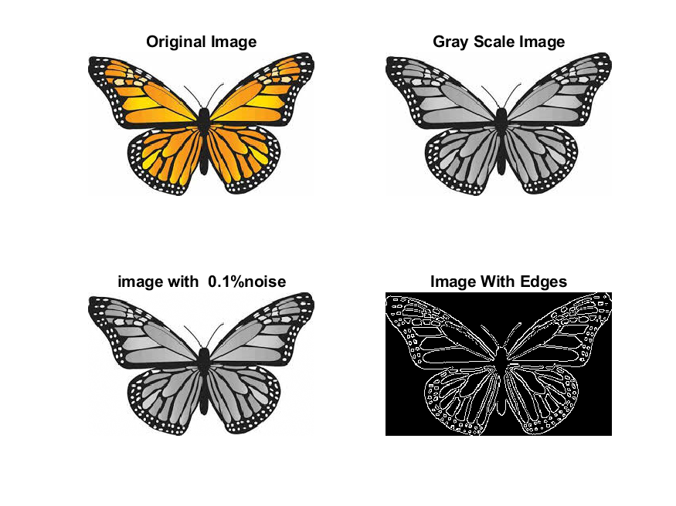

**Image 2:-10 % Noise**

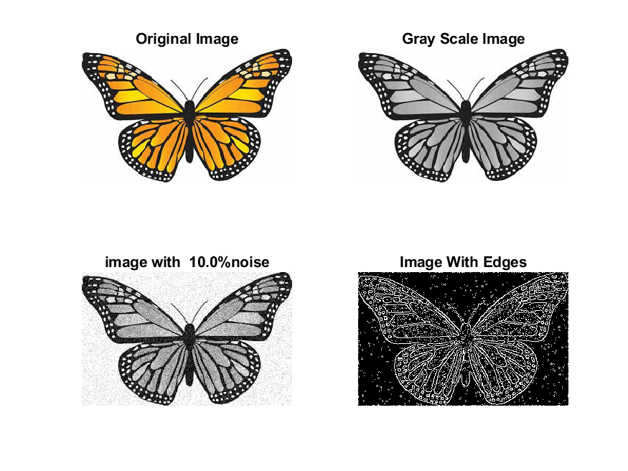

**Image 3:-20 % Noise**

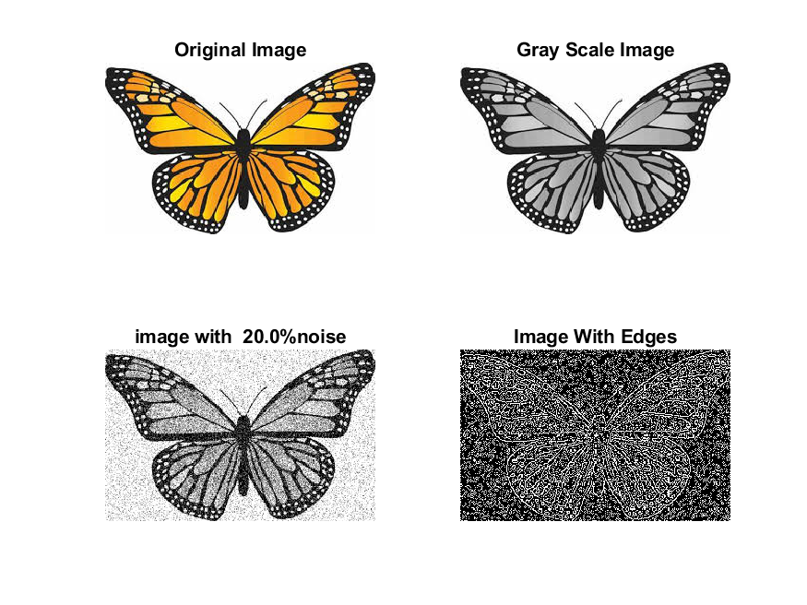

**Image 4:-30 % Noise**

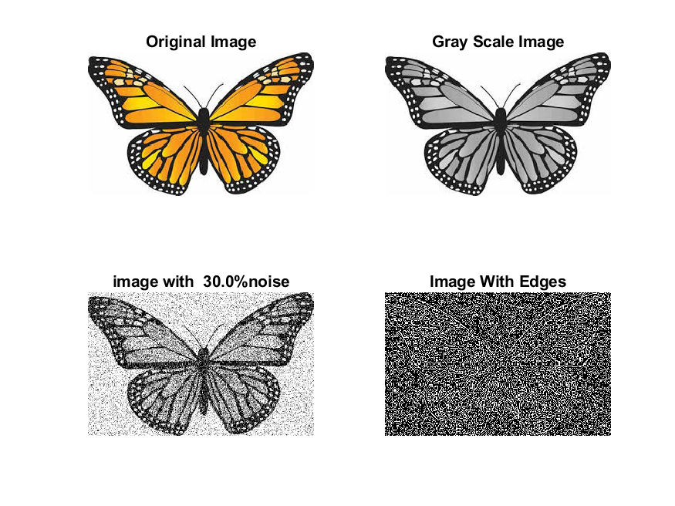

|  |
| --- |
| **Image 5:-40 % Noise** |

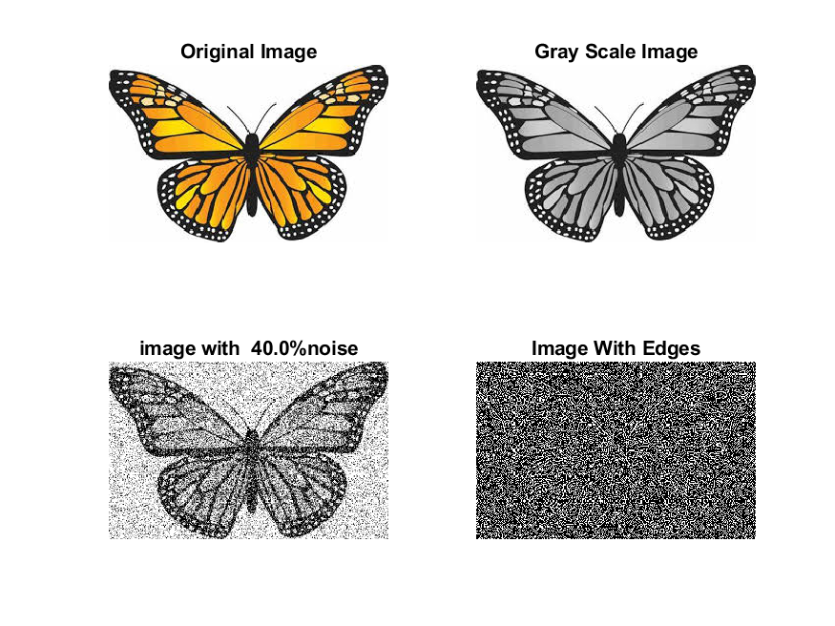

**Image 6:-50 % Noise**

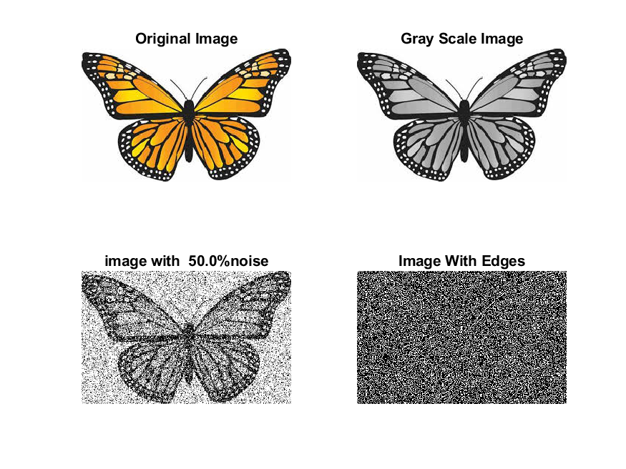

**Image 7:-60 % Noise**

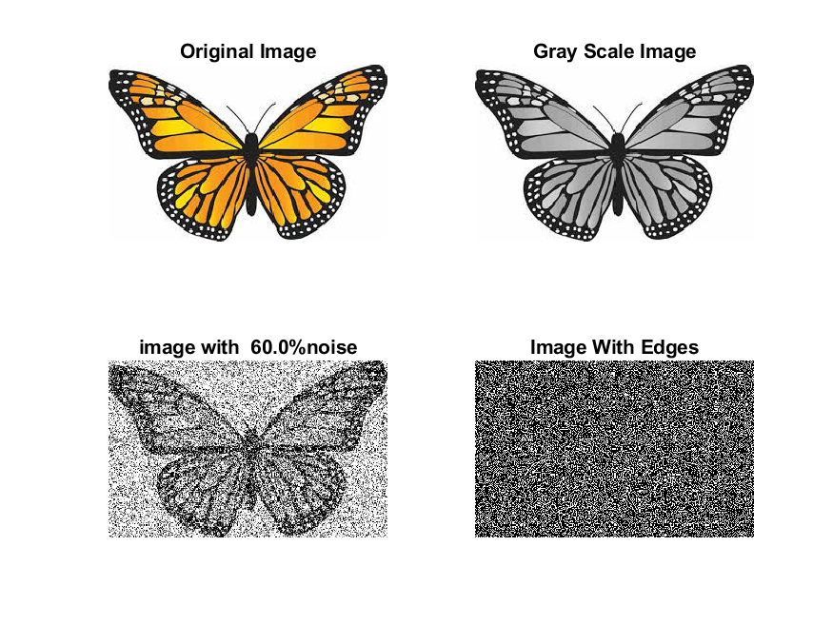

**Image 8:-70 % Noise**

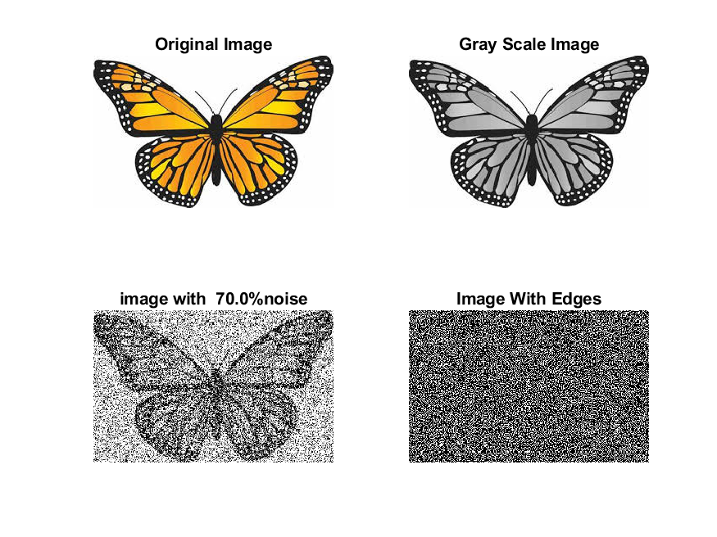

**Image 9:-80 % Noise**

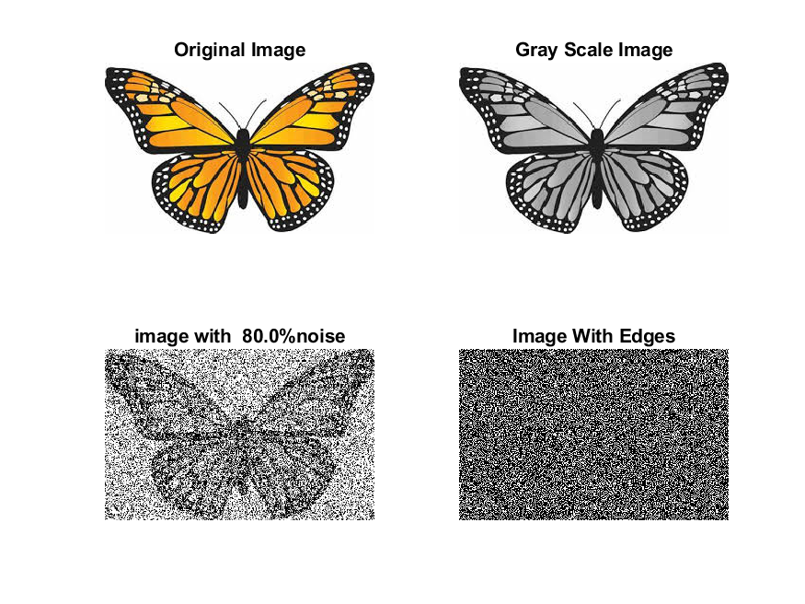

**DATA FILES**

**Image 1:-Noise0.1**

Original image ideal values:

IM1 image entropy:5.608976e-01

IM1 image mean:0.131265

Ground truth image entropy:0.968631

Ground truth image mean:0.396113

entropy between imt and im1 :0.896052

MSE between imt and im1 :0.360177

Average Difference between imt and im1 :0.264848

Maximum Difference between imt and im1 :1.000000

True Positive values:4220.000000

False Positive values: 2406.000000

True Negative values:28077.000000

False Negative values:15775.000000

Accuracy value: 0.639823

F Measure values:0.317043

Peak Signal-to Noise Ration value: 4.434844

Signal-to Noise Ration value: -4.796700

percentage of pixels that were correctly detected (Pco): 0.211053

The percentage of pixels that were not detected (Pnd):0.788947

the percentage of false alarm: (Pfa):0.120330

Euclidean Distance Value :20.137998

**Image 2:-Noise10**

Original image ideal values:

IM1 image entropy:6.827980e-01

IM1 image mean:0.181247

Ground truth image entropy:0.968631

Ground truth image mean:0.396113

entropy between imt and im1 :0.872614

MSE between imt and im1 :0.371211

Average Difference between imt and im1 :0.214866

Maximum Difference between imt and im1 :1.000000

True Positive values:5203.000000

False Positive values: 3946.000000

True Negative values:26537.000000

False Negative values:14792.000000

Accuracy value: 0.628789

F Measure values:0.357055

Peak Signal-to Noise Ration value: 4.303789

Signal-to Noise Ration value: -3.395478

percentage of pixels that were correctly detected (Pco): 0.260215

The percentage of pixels that were not detected (Pnd):0.739785

the percentage of false alarm: (Pfa):0.197349

Euclidean Distance Value :25.046776

**Image 3:-Noise20**

Original image ideal values:

IM1 image entropy:8.760120e-01

IM1 image mean:0.295733

Ground truth image entropy:0.968631

Ground truth image mean:0.396113

entropy between imt and im1 :0.836647

MSE between imt and im1 :0.432961

Average Difference between imt and im1 :0.100380

Maximum Difference between imt and im1 :1.000000

True Positive values:6534.000000

False Positive values: 8394.000000

True Negative values:22089.000000

False Negative values:13461.000000

Accuracy value: 0.567039

F Measure values:0.374195

Peak Signal-to Noise Ration value: 3.635513

Signal-to Noise Ration value: -1.269198

percentage of pixels that were correctly detected (Pco): 0.326782

The percentage of pixels that were not detected (Pnd):0.673218

the percentage of false alarm: (Pfa):0.419805

Euclidean Distance Value :31.697885

**Image 4:-Noise30**

Original image ideal values:

IM1 image entropy:9.157190e-01

IM1 image mean:0.330778

Ground truth image entropy:0.968631

Ground truth image mean:0.396113

entropy between imt and im1 :0.826828

MSE between imt and im1 :0.454772

Average Difference between imt and im1 :0.065335

Maximum Difference between imt and im1 :1.000000

True Positive values:6868.000000

False Positive values: 9829.000000

True Negative values:20654.000000

False Negative values:13127.000000

Accuracy value: 0.545228

F Measure values:0.374360

Peak Signal-to Noise Ration value: 3.422059

Signal-to Noise Ration value: -0.782830

percentage of pixels that were correctly detected (Pco): 0.343486

The percentage of pixels that were not detected (Pnd):0.656514

the percentage of false alarm: (Pfa):0.491573

Euclidean Distance Value :33.369675

**Image 5:-Noise40**

Original image ideal values:

IM1 image entropy:9.250362e-01

IM1 image mean:0.340227

Ground truth image entropy:0.968631

Ground truth image mean:0.396113

entropy between imt and im1 :0.828318

MSE between imt and im1 :0.466203

Average Difference between imt and im1 :0.055886

Maximum Difference between imt and im1 :1.000000

True Positive values:6818.000000

False Positive values: 10356.000000

True Negative values:20127.000000

False Negative values:13177.000000

Accuracy value: 0.533797

F Measure values:0.366865

Peak Signal-to Noise Ration value: 3.314248

Signal-to Noise Ration value: -0.660499

percentage of pixels that were correctly detected (Pco): 0.340985

The percentage of pixels that were not detected (Pnd):0.659015

the percentage of false alarm: (Pfa):0.517929

Euclidean Distance Value :33.120238

**Image 6:-Noise50**

Original image ideal values:

IM1 image entropy:9.281621e-01

IM1 image mean:0.343536

Ground truth image entropy:0.968631

Ground truth image mean:0.396113

entropy between imt and im1 :0.823371

MSE between imt and im1 :0.462974

Average Difference between imt and im1 :0.052577

Maximum Difference between imt and im1 :1.000000

True Positive values:6983.000000

False Positive values: 10358.000000

True Negative values:20125.000000

False Negative values:13012.000000

Accuracy value: 0.537026

F Measure values:0.374063

Peak Signal-to Noise Ration value: 3.344434

Signal-to Noise Ration value: -0.618473

percentage of pixels that were correctly detected (Pco): 0.349237

The percentage of pixels that were not detected (Pnd):0.650763

the percentage of false alarm: (Pfa):0.518030

Euclidean Distance Value :33.944710

**Image 7:-Noise60**

Original image ideal values:

IM1 image entropy:9.281251e-01

IM1 image mean:0.343496

Ground truth image entropy:0.968631

Ground truth image mean:0.396113

entropy between imt and im1 :0.825119

MSE between imt and im1 :0.465232

Average Difference between imt and im1 :0.052617

Maximum Difference between imt and im1 :1.000000

True Positive values:6925.000000

False Positive values: 10414.000000

True Negative values:20069.000000

False Negative values:13070.000000

Accuracy value: 0.534768

F Measure values:0.370976

Peak Signal-to Noise Ration value: 3.323301

Signal-to Noise Ration value: -0.618974

percentage of pixels that were correctly detected (Pco): 0.346337

The percentage of pixels that were not detected (Pnd):0.653663

the percentage of false alarm: (Pfa):0.520830

Euclidean Distance Value :33.654935

**Image 8:-Noise70**

Original image ideal values:

IM1 image entropy:9.302740e-01

IM1 image mean:0.345814

Ground truth image entropy:0.968631

Ground truth image mean:0.396113

entropy between imt and im1 :0.824698

MSE between imt and im1 :0.466996

Average Difference between imt and im1 :0.050299

Maximum Difference between imt and im1 :1.000000

True Positive values:6939.000000

False Positive values: 10517.000000

True Negative values:19966.000000

False Negative values:13056.000000

Accuracy value: 0.533004

F Measure values:0.370564

Peak Signal-to Noise Ration value: 3.306873

Signal-to Noise Ration value: -0.589767

percentage of pixels that were correctly detected (Pco): 0.347037

The percentage of pixels that were not detected (Pnd):0.652963

the percentage of false alarm: (Pfa):0.525981

Euclidean Distance Value :33.724971

**Image 9:-Noise80**

Original image ideal values:

IM1 image entropy:9.317416e-01

IM1 image mean:0.347419

Ground truth image entropy:0.968631

Ground truth image mean:0.396113

entropy between imt and im1 :0.823220

MSE between imt and im1 :0.466659

Average Difference between imt and im1 :0.048694

Maximum Difference between imt and im1 :1.000000

True Positive values:6988.000000

False Positive values: 10549.000000

True Negative values:19934.000000

False Negative values:13007.000000

Accuracy value: 0.533341

F Measure values:0.372376

Peak Signal-to Noise Ration value: 3.310006

Signal-to Noise Ration value: -0.569661

percentage of pixels that were correctly detected (Pco): 0.349487

The percentage of pixels that were not detected (Pnd):0.650513

the percentage of false alarm: (Pfa):0.527582

Euclidean Distance Value :33.969842